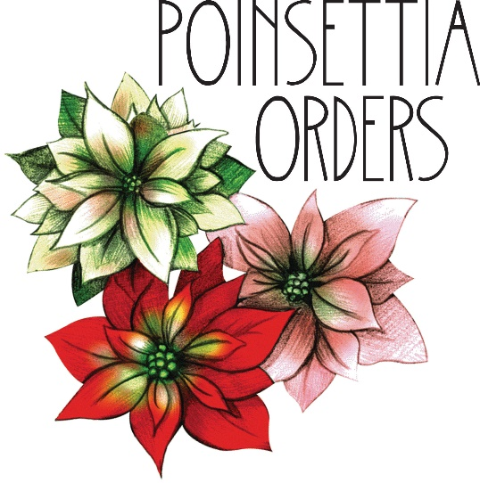

Orders should be in the church office by Monday, December 20. The cost is $15.00. Please download and complete this form and place it in the offering plate, leave it in the church office or email it as an attachment. You may also call 703-573-0295 or email secretary@stpaulsfallschurch.org including the information below to place your order. Payment may be submitted with your order, sent separately, or paid online; put “poinsettias” in the memo line or description box.

You may pick up your poinsettia after the 10:00 a.m. Christmas Day Service. Poinsettias not picked up at that time may be picked up during the following week.

No. of plants _______

Your name ________________________________________

Telephone/email_____________________________________________________________________________________________

Message you wish included in the insert (please write legibly):

____________________________________________________________________________

____________________________________________________________________________

____________________________________________________________________________

